User Login — Functional / UI Specification
LOG-01 | Design approved; specification for review | v1.0 | 27 October 2026
Scope: Entry authentication for Coach and Admin accounts. Account creation, initialization, role administration and backend management are separate workflows.

1. Source and approval boundary
Source: “WorkFlow Stage 2”, section 5 “User Log In”, pages 11–12 (continuation on p.12). The approved discussion replaces its requested Admin/Coach selector with automatic role determination from the authenticated account. The document’s example account credentials are deliberately excluded from this specification.

2. Functional requirements
ID | Requirement / behavior | Status
LOG-01 | Username or email + password; no role selector on login form. | Approved
LOG-02 | Credentials identify account; system reads assigned Coach/Admin role. User cannot self-select privileges. | Approved
LOG-03 | Successful authentication navigates to the shared Home Page. | Approved
LOG-04 | Invalid credentials: show a non-revealing error; remain on Login page. | From workflow
LOG-05 | Keep me signed in is enabled by default; returning users with valid sessions skip login. | Approved
LOG-06 | Coach: all approved coaching workflows, excluding user account and backend data administration. | Approved
LOG-07 | Admin: coaching functions plus account/backend administration, subject to server-enforced permissions. | Approved
LOG-08 | Separate Account Initialization and Management workflow. | Approved scope

3. Login UI
- EchoCoach branding, “Welcome Back” heading, username/email field, password field with Show/Hide option.
- Keep me signed in checkbox (checked by default); primary Log In action; Forgot password entry point.
- No Admin/Coach switch, no class or student content, no sport choice on this page.
- The approved PNG displays Tennis artwork as a visual example. Authentication itself must be sport-independent; final branding treatment can be shared/generic.

4. Navigation and error states
Case | Expected outcome
Valid existing session | Open shared Home without asking for credentials again.
No session / expired session | Open Login.
Valid login | Establish secure session and open Home; privileges reflect account role.
Incorrect credentials | Stay on Login; show generic authentication failure without disclosing whether account exists.
Network/service error | Stay on Login; show retryable service error, distinct from invalid credentials.
Logout | End session and return to Login.

5. Role and data-access safeguards
- The server must independently check user identity, role and resource ownership for protected operations; hiding Admin menus in the UI is insufficient.
- Each coach may access only records allowed for that coach. Admin access follows the separately approved administration policy.
- Sessions and secrets must be handled through the selected authentication provider / secure OS storage; do not write passwords or tokens into project source or plain local storage.
- Password reset is a visible UI entry point, but its detailed process/provider is not specified by this module.

6. Acceptance criteria
- A Coach signs in and reaches Home without a role choice; account/admin management operations remain inaccessible.
- An Admin signs in using the same form and reaches the same Home while retaining authorized administration access.
- Choosing any route or client-side parameter cannot elevate a Coach to Admin.
- A valid remembered session bypasses login on reopening the app; an expired or revoked session returns to Login.
- Authentication failure never opens Home and does not disclose account existence.
- Logout clears the app session and prevents access to protected data until reauthentication.

7. Outside scope / implementation follow-up
- Account initialization, invitations, registration, reset-email delivery and user account management are separate design work.
- Select authentication provider, token/session lifetime, password reset process, rate limiting, account lockout and multi-device behavior during implementation review.
- Decide final sport-neutral login artwork during visual integration; the approved mockup uses Tennis styling as an example.
- Do not copy test passwords from the source workflow document into repository documentation, database seeds or demonstrations.

Approved visual reference — LOG-01
The following image is the approved Login visual (role selector removed). The UI is a reference, not an authentication implementation.
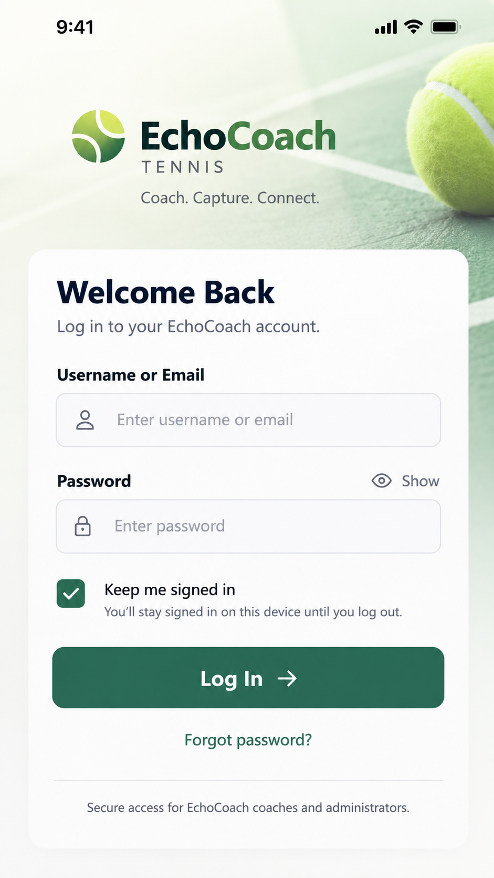
Visual Log asset: LOG-01_User-Login_Approved_v1.png

